Year 9 Science Skills Practice

**Dataset 1:**

27oC it began to decrease

Began to plateau

22

20oC

7.5

Temperature

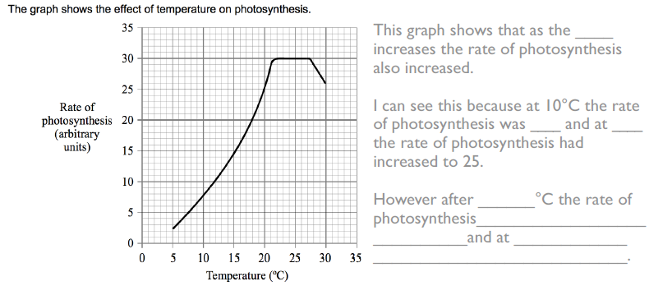

**Dataset 2:**

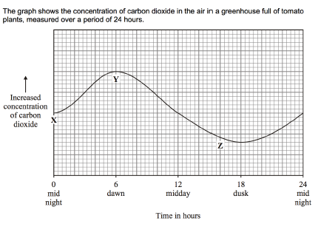

1. Carbon dioxide is used by the tomato plants during photosynthesis. Based on this information and the graph, **identify** at which point (X, Y or Z) the rate of photosynthesis of the tomato plants was the highest.

Point Z has the highest rate of photosynthesis as it is the point with the lowest concentration of carbon dioxide. As carbon dioxide is being used in photosynthesis, it can be assumed that the point with the lowest carbon dioxide would have the highest rate of photosynthesis. Point Y would have the lowest rate of photosynthesis as it has the highest concentration of carbon dioxide.

1. Based on the graph, **describe** at which time of the day the rate of photosynthesis is the greatest. **Compare** this to the time of day at which the rate of photosynthesis is the lowest.

The concentration of carbon dioxide is lowest at 18 hours past midnight (dusk) and is the highest at 6 (dawn). Therefore, the highest rate of photosynthesis occurs at dusk and the lowest rate occurs at dawn.

**Dataset 3:**

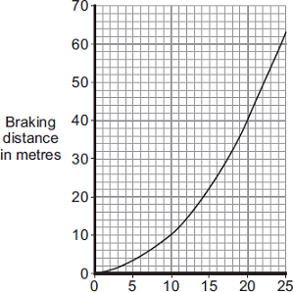

**Speed (m/s)**

**Graph 3:** The effect of speed of a car on braking distance

1. **Describe** the trend shown in graph 3.

As the speed of the car increases, the braking distance also increases

1. **Identify** at what speed the car was travelling, to have a braking distance of:
2. 10m

10m/s

1. 20m

14m/s

1. 60m

24.5m/s

1. **Identify** the braking distance of the car if it is travelling at:
2. 5m/s

4m

1. 14m/s

20m

1. 20m/s

40m

**Dataset 4**

Zara is doing her sprint training. The graphs below show how her distance changes during one run.

1. What does the part of the graph **between X and Y** tell you about Zara?

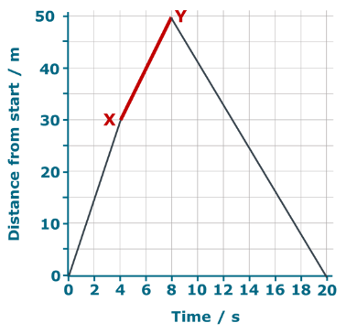Put a tick (✓) in the box next to the best answer.

|  |  |  |
| --- | --- | --- |
| **A** | She climbs a 20m hill |  |
|  |  |  |
| **B** | She runs 50m |  |
|  |  |  |
| **C** | She runs 20m in 8 seconds |  |
|  |  |  |
| **D** | She runs 20m in 4 seconds | ✓ |

1. Where is Zara when she reaches the **point marked Z**?

Put a tick (✓) in the box next to the best answer.

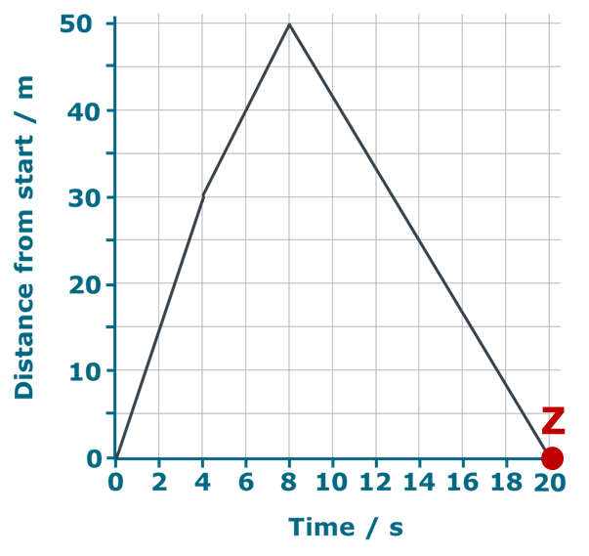

|  |  |  |
| --- | --- | --- |
| **A** | Back to the start | ✓ |
|  |  |  |
| **B** | 50m from the start |  |
|  |  |  |
| **C** | 100m from the start |  |
|  |  |  |
| **D** | You can’t tell |  |

**Dataset 5:**

Mohammed runs fast for 10 seconds. The results are recorded in the graph below.

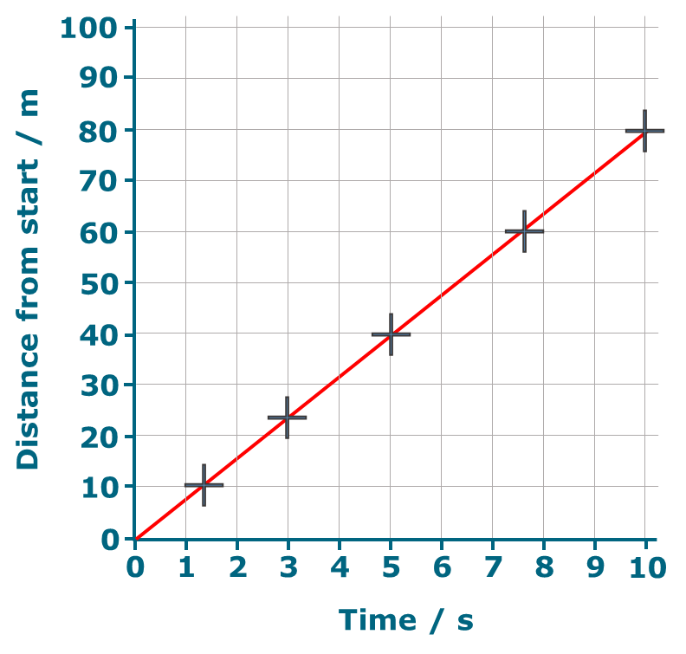

**Graph 4:** The distance run by Mohammed over 10 seconds.

1. Use the graph above to match the correct distance to each time.

5 s

10 s

7.5 s

3 s

6 s

25 m

40 m

46 m

48 m

60 m

23 m

80 m

**Time**

**Distance**

1. Use the graph to match the correct distance to each time.

Rule a line between each time and the correct distance

70 m

60 m

40 m

30 m

55 m

4 s

5 s

6.9 s

7 s

7.5 s

3.8 s

8.8 s

**Distance**

**Time**

.

**Dataset 6:**

A nuclear scientist was investigating the properties of a radioisotope, X. The scientist placed a sample of radioactive X near the counter and measured the radiation counts each Monday for 7 weeks, counting the first week as week 0. Her results are shown in the table.

1. Complete the table by writing in the values for the third column.

|  |  |  |  |
| --- | --- | --- | --- |
| Week | Total radiation counts recorded (counts min-1) | Background radiation (counts min-1) | Radiation due to X (counts min-1) |
| 0 | 1031 | 46 | 985 |
| 1 | 848 | 46 | 802 |
| 2 | 698 | 46 | 652 |
| 3 | 566 | 46 | 520 |
| 4 | 476 | 46 | 430 |
| 5 | 395 | 46 | 349 |
| 6 | 328 | 46 | 282 |

1. On the grid below, plot the results to show the relationship between time and the radiation of X
2. Use your graph to determine the half-life of X.

Approximately 3.5 weeks

1. **Predict** the radiation in counts min-1 of X for day 10.

Approximately 750 counts min-1

1. **Predict** the radiation in counts min-1 of X for day 38.

Approximately 300 counts min-1

**Dataset 7**

The graph below shows the activity of a radioisotope over time.

1. **Identify** the activity of the radioisotope at 25 hours.

30 counts per second

1. **Predict** the half-life of the radioisotope.

15 hours

1. The half-life of radioactive caesium-137 is about 30 years. This means that after 30 years the mass of a sample of caesium-137 will have halved, regardless of its starting mass. If there is a sample of 40 grams of radioactive caesium-137, **calculate** how many years will it take for its mass to decrease to 2.5 grams?

1st half-life: $\frac{40}{2}=20g$

2nd half-life: $\frac{20}{2}=10g$

3rd half-life: $\frac{10}{2}=5g$

4th half-life: $\frac{5}{2}=2.5g$

It takes 4 half-lives to get to a mass of 2.5g.

4 x 30 years = 120 years.

It will take 120 years for a 40g mass of caesium-137 to decay to 2.5 grams

1. Suppose we start with 1 gram of I-131, which has a half-life of 8 days. **Calculate** the amount of I-131 that would remain after 6 half-lives.

1st half-life: $\frac{1}{2}=0.5g$

2nd half-life: $\frac{0.5}{2}=0.25g$

3rd half-life: $\frac{0.25}{2}=0.125g$

4th half-life: $\frac{0.125}{2}=0.0625g$

5th half-life: $\frac{0.0625}{2}=0.03125g$

6th half-life: $\frac{0.03125}{2}=0.015625g$

**Dataset 8**

A 1cm piece of magnesium ribbon was placed into solutions of different pH’s. The time for the magnesium to dissolve was recorded.

1. Predict the time it would take to dissolve the strip of magnesium if a solution had a pH of 1.5

45 sec

1. What is the relationship between pH and the time to dissolve magnesium.

As pH increases, time to dissolve magnesium increases

1. Using your understanding of the pH scale and concentration of H+ ions, explain why the pH 1 solution dissolved the magnesium at a different rate than the pH 4 solution.

pH 1 solutions have more H+ ions than pH 4 solutions. Therefore there are more ions available to react with the magnesium, which causes the reaction to occur faster.